|  |  |  |
| --- | --- | --- |
| Q:\Vorlagen\ITK-Logos\ITK_Logo_RGB_Dokumentvorlage_gross.png | IT handbook |  |
|  | ITK Engineering GmbH | www.itk-engineering.de | info@itk-engineering.de | |
|  | ITK CN | |
| V:\01_Vorlagen\Leiterplatte.png |  | |
| – vertraulich – | | |

IT handbook

ITK CN

Table of contents

1 Introduction 2

2 IT Ticket System 2

2.1 Issue 2

2.2 Service Catalog 3

3 Outlook Certificates 3

3.1 Create certificates 3

3.1.1 Set high security level 6

3.2 Use certificates 8

3.2.1 Verify certificate 9

4 WiFi 11

5 Kind of user accounts provided by IT 11

6 Confluence 12

7 Jira 12

8 Printer 12

9 Software list 12

10 Stages 12

11 German <-> English Translation 13

12 Personal drive 13

13 Access-Management Tool 13

14 Cloud Workplace 13

# Introduction

The scope of the handbook is to provide an overview of the standard tasks and requests of every new employee regarding IT topics within ITK.

Please be aware: IT support is only to be requested at the ITK IT department. Please do not directly contact CI for support.

# IT support

IT support is provided by the ITKG\ICO. Please do not contact CI support. In case ITK cannot provide specific Bosch support, ITKG\ICO will forward the support case to CI.

# IT Ticket System

<https://itservice.itk-engineering.de/HEAT/Default.aspx>

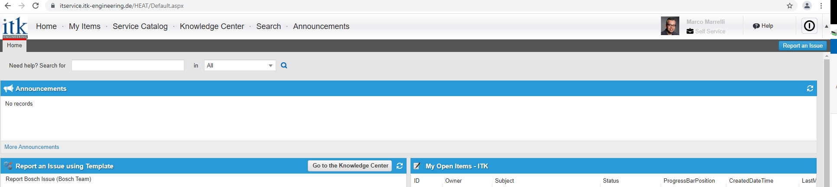

## Issue

If you have issues with some service, for example the service is not working as expected, please “report an issue”

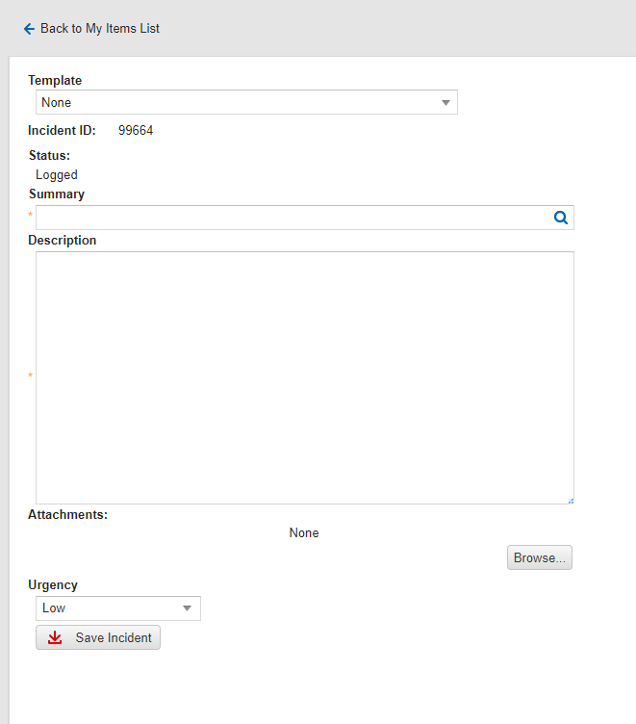

## Service Catalog



Use the service catalog to request new services or changes:

Ein Bild, das Text enthält.

# Outlook Certificates

## Create certificates

If you do not yet have certificates, the following icon appears in the taskbar:





If this icon does not appear, - please use the certmgr.msc command to start the certificate manager - navigate to the subfolder "Certificates" in the folder structure on the left - right-click on the background to open a menu "All tasks" "Request new certificate"

Now the wizard starts as described in point two.

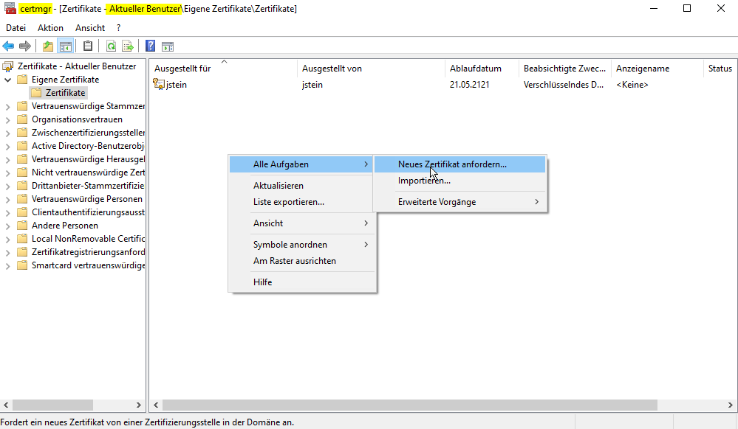

Click on the certificate icon to open the wizard:

Ein Bild, das Text enthält.

A click on "Next" starts the workflow:

For ITC 2 S/MIME certificates are used:

- User, Auth and encryption -> Encrypted emails

- User, Signature -> Signing of emails or documents (Sign)

Ein Bild, das Text enthält.

To select the security level, click Security level...

**Recommendation!**

**The middle security level is sufficient! Should you still choose the high security level, make sure that you do not forget the password! This cannot be changed/read by the IT.**

Ein Bild, das Text enthält.

### Set high security level

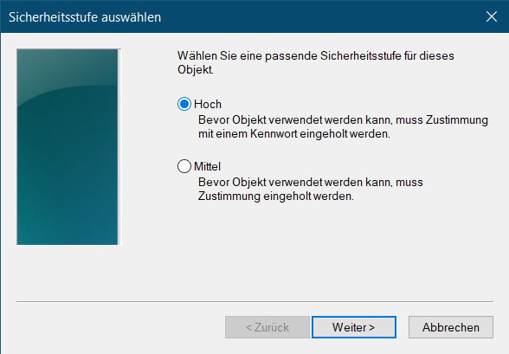

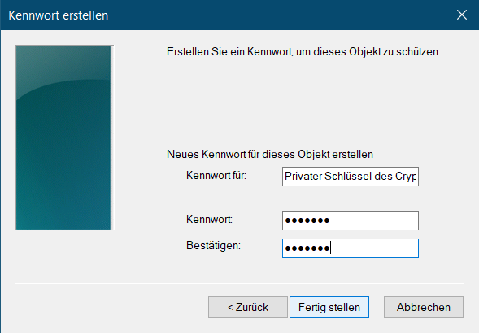

Ein Bild, das Text enthält.

Here you have to enter the password, which was assigned in the previous step.

Ein Bild, das Text enthält.

**This step is performed twice (once for the signature certificate and once for the encryption certificate).**

A password must be given here, which you should remember (or place in the Keepass)!

**IT has no way to recover this password!**

If you have only chosen the security level "Media" during registration, you must export the certificates and import them again!

**See Export and Import of Certificates**

**Important information:**

Please note that it may take up to 48h for the public part of your certificates to be distributed over the address list. Until then it can happen that no encrypted mail can be sent to you!

IT can only restore the user, auth and encryption (ITK)" certificate! In case of loss of the User, Signature (ITK)" certificate (or password), it can only be blocked and issued again!

**Never! Really NEVER! Manually issue a certificate! Otherwise there will be problems with the renewal of the (the) certificate!**

## Use certificates

In order for you to sign or encrypt your mails, the created certificates must be stored in Outlook.

In Outlook click on File -> Options:

Then on **Trust Center** -> Settings for the Trust Center

E-mail security -> S/MIME...

Both signature certificate and encryption certificate must be selected!

***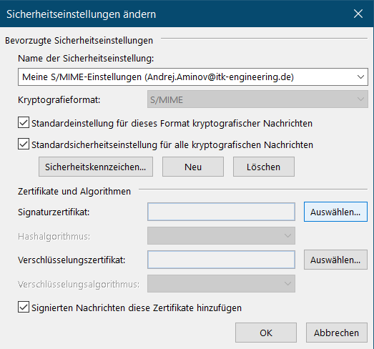***

As a rule, the correct certificate is automatically recognized and you can simply click "OK". However, below is described how to check the correctness manually.

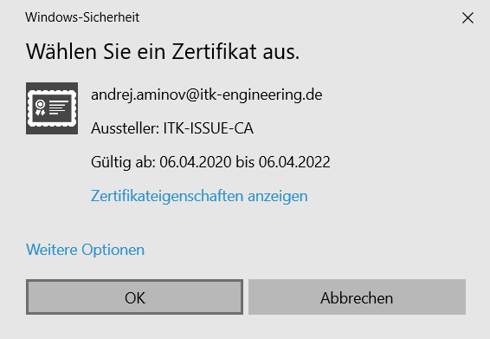

**After both certificates have been selected, the hash algorithm must be changed to SHA512!**

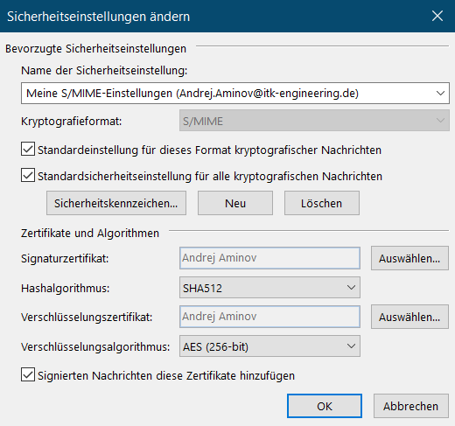

### Verify certificate

If you click on "More options" you will see an identical window as in the following screenshot.

First you click on the certificate you want to check and then on "View certificate properties.

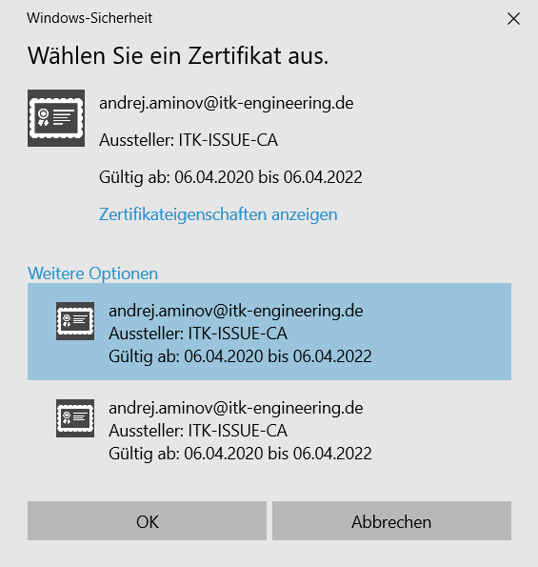

The screenshots below show the field to be followed.

The certificate with the = User, Signature (ITK)" template is selected as the signature certificate.

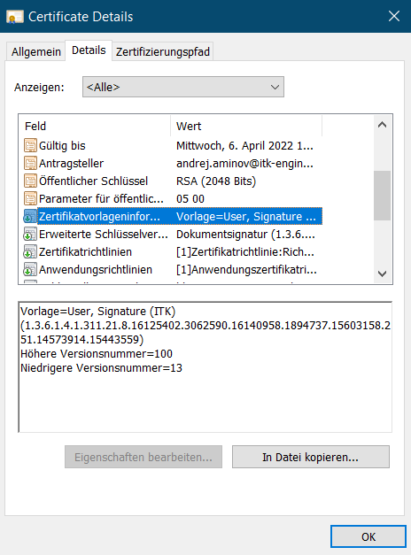

The certificate with the "= User, Auth and encryption (ITK)" template is selected as the encryption certificate.

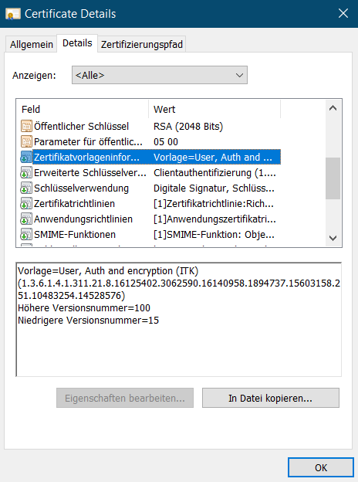

# WiFi

* ITK WiFi:
  + used for ITK managed Laptops. Will connect automatically
* ITK Mobil WiFi:
  + used for ITK manged IPhones. Will connect manually
* ITK Guest WiFi
  + Used for ITK guest. Access though Sponsorship. Guests can register on the ITK-Guest Wifi via an ITK employee who serves as a sponsor. To do this, the guest first connects to the ITK-Guest Wifi and registers by specifying their host as the sponsor. The ITK employee receives an e-mail and can activate his guest in the ITK-Guest Wifi.

# New Laptops and new IPhones

New devices need to be registered on our ITK asset database to service them by out 1st level IT support. If you have bought new devices, please contact [IT@itk-engineering.de](mailto:IT@itk-engineering.de) and either notify us about the laptop MAC address, or the IPhone IMEI and serial number.

# Kind of user accounts provided by IT

Your **ITK account:** for example: ITK\mmarrelli with email [marco.marrelli@itk-engineering.de](mailto:marco.marrelli@itk-engineering.de) or .com

Used in ITK provided applications

**BCD account**: Used for proxy authentication to access the Bosch network. For example: APAC\MAM1RLZ

Ein Bild, das Text enthält.

**IDM Account:** Used for Bosch provided application**.** For example: MAM1RLZ

# Confluence

Also known as the ITK intranet [Übersicht - ITK Confluence (itk-engineering.de)](https://confluence.itk-engineering.de/index.action#all-updates)

A lot of ITK public information (mainly in German) but also spaces for teams, projects, etc.

# Jira

[System Dashboard - ITK Jira (itk-engineering.de)](https://jira.itk-engineering.de/secure/Dashboard.jspa) Ticket system used for all kinds of ITK internal processes, QM, purchasing etc.

# Printer

The printer in the Wuxi office is called Wx11-Cx921de\_1 an wx11v-file001. Please use the ‘add printer feature’ from Windows to search and add the printer to your client.

# Software list

[ITK software list - ITK Informationssicherheit - ITK Confluence (itk-engineering.de)](https://confluence.itk-engineering.de/display/INFSEC/ITK+software+list)

@ITK software is mainly installed by the individual ITK employee with admin access on the laptops. But only software that is approved by the Information-Security department may be installed. You can see the current state of approved/rejected software in this list. (You can request software evaluation for software not on this list by IT ticket system)

# Stages

[ITK Stages Login (itk-engineering.de)](https://stages.itk-engineering.de/pkit/main.do) QM process platform. Included ITK processes, handbooks, policies, guidelines etc.

# German <-> English Translation

[Reverso Corporate - Text translation (bosch.com)](https://rb-reverso6-p.de.bosch.com/en) can be used to translate PDF’s, DOCX PPTX, …

Please be aware, other online or cloud translation services must not be used because the translated data gets store in the online service.

I used this service to translate confluence information, by saving it as docx and translating it with reverso.

# Personal drive

Every user gets a personal drive mapped U: on his laptop.

# Access-Management Tool

<https://accessmanagement.itk-engineering.de/>

Among others: request admin rights or Mass Storage (USB drive) capability on your device

# Cloud Workplace

The Cloud Workplace is a virtual desktop located in the Bosch network. It is accessible by this link [Citrix Workspace (bosch.com)](https://rb-cloudworkplace-internal-emea.bosch.com/Citrix/BoschCloudWorkplaceWeb/). Login is done by BCD user. See chapter 4 for information about users.

The Cloud workplace is used for all kind of Bosch services and the preferred way of connecting to the Bosch world, due to the high latency between the ITK network and the Bosch network.

# Outlook online page

If you have urgent case, can’t use ITK laptop to login outlook, you can use this online page in your own computer: <https://owa.itk-engineering.de>

# Teams

All ITKC employees should install teams in your own phone for emergency contact.